Najin Khoerus syakirin

1207070082

Percobaan 1

Percobaan 2

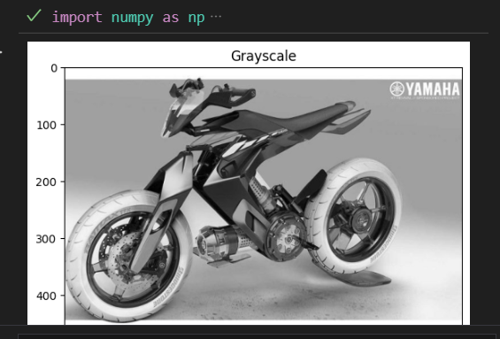

Percobaan 3

